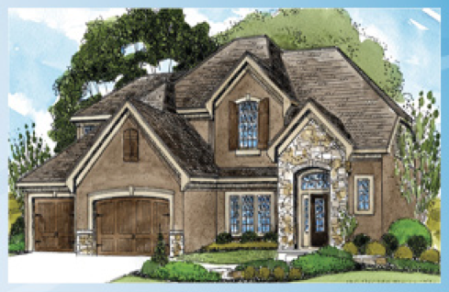
Step 1: list (5 pts)
Compose a list of the rooms you’ll be including in your house (at least 2 bedrooms, 2 bathrooms, a kitchen, a living room and a garage). You may include as many rooms as you’d like keeping in mind that you’ll probably need a hallway or two, doors and windows. BE CREATIVE as this is your dream house you may also include a movie theater, a bowling alley, etc.

Step 2: draw floor plans (10 pts)
Remember to stay on the lines of the graph paper so you are able to easily calculate the square footage (area) of your home. If you draw in between the marked gridlines you’ll be making it pretty tricky to figure all that out. Put a label in the middle of each room to identify it.

Step 3: calculate square footage (20 pts)
When someone is looking into buying or building a home, they are usually asked how many square feet they’d like. Square footage is the amount of living space in the home. The garage is NOT included in this calculation! Calculate the square footage of each of your rooms; each square represents one foot. Write the dimensions of the room under the label and calculate the area. Write that number next to the dimensions. On the bottom right corner of the graph paper, indicate what the total square footage is for the floor (add all the rooms on that floor together).

Step 4: design your home (10 pts)
On a plain white piece of paper draw a picture of what your home would look like from the outside. Think about if you’d have brick, stone or siding on your house. Will you have shutters on your windows? Will there be a chimney for a fireplace? Are all of your windows going to be rectangular or will some be circles or semi-circles? Color your home and don’t forget about the landscaping and driveway!

